2021

**Prepared By:**

**Angrej Singh**

Project Proposal Property Sales

Contents

Project Proposal 2

Goals and Objectives 2

Scope and Deliverables 2

Project Scope 2

Project Deliverables 2

Project Specification and Target Audience 3

Project Schedule and milestones 3

Resources Required 3

Functionality and Non-Functionality of Project 3

Functionalities 3

Non-Functionalities 3

Assumptions 4

Detailed Design 5

Home Page 5

Login Page 5

Admin Register Property Page 6

Admin Buyer Page 7

Admin Sales Transaction Page 7

User Registered Property Page 8

User Property Confirm Page 9

Project Testing 9

User Activities 10

Admin Activities 10

# Project Proposal

## Goals and Objectives

The main aim of this project is to build an online web application named as “Property sales”. In this application there are two parts Admin and user. The rights of admin and user varies. Admin can register, update, remove, and can check the details of the property. He/she can register the new property as well. Also, the admin can delete and check the details of the buyers. Admin can delete sales transactions and check the details of the transaction. Further, users can login to the system by using their credentials and new users can signup in the application by registering themselves. Users can buy properties and ca confirm the sale of the property.

## Scope and Deliverables

## Project Scope

The duration for this project is 3 weeks. The scope of the project is to implement the admin functionality such as add, update, delete ( Curd Operation ). For users to implement the functionality of buy and confirmation of sale. Also, we have to test all of the functionalities of the application.

## Project Deliverables

To achieve the goal of our project, we have set the following deliverables:

* Planning of Project
* Designing
* Coding
* Demonstration
* Testing
* Documentation Of Project

## Project Specification and Target Audience

* Secure Login and Logout for both admin and user.
* Add, update, delete and details function should work properly.
* User can able to view Property, buy Property, and confirm sale of Property.

The Target audience for this web application will be the people who are willing to buy a house in New Zealand.

# Project Schedule and milestones

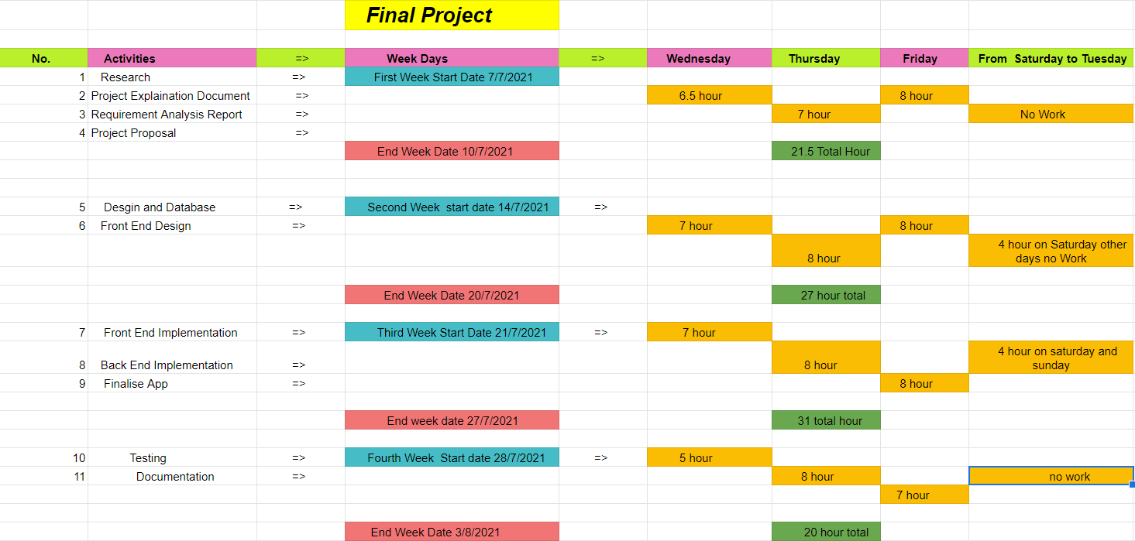

# Resources Required

The Following are resources required to complete this project:

* ASP.Net MVC and Identity Framework
* Windows OS 10
* Minimum i5 processor with 4-8 GB of RAM
* MS Word, Excel

# Functionality and Non-Functionality of Project

The functional and non-functional area of the project are as below:

## Functionalites

* The application should allow a new user to register.
* Existing users can login and view the listed properties.
* Admin can manage the properties, buyers and sales transaction for the application
* Admin can perform add, update, edit and delete functions successfully.

## Non-Functionalites

* The loading speed of the application should be fast.
* Multiple browser and device support.
* Accessibility and usability of the application..

## Assumptions of the Project

Following are some assumptions which I made during this project:

* The availability of a user has been considered as available all time for feedback.
* Minimum One user and admin will be registered with the application.
* Web Applications will be free of charge.
* Anyone can register with the application.
* Initially one admin will be there and later more than one admin can be created.

# 

# Detailed Design

## Home Page

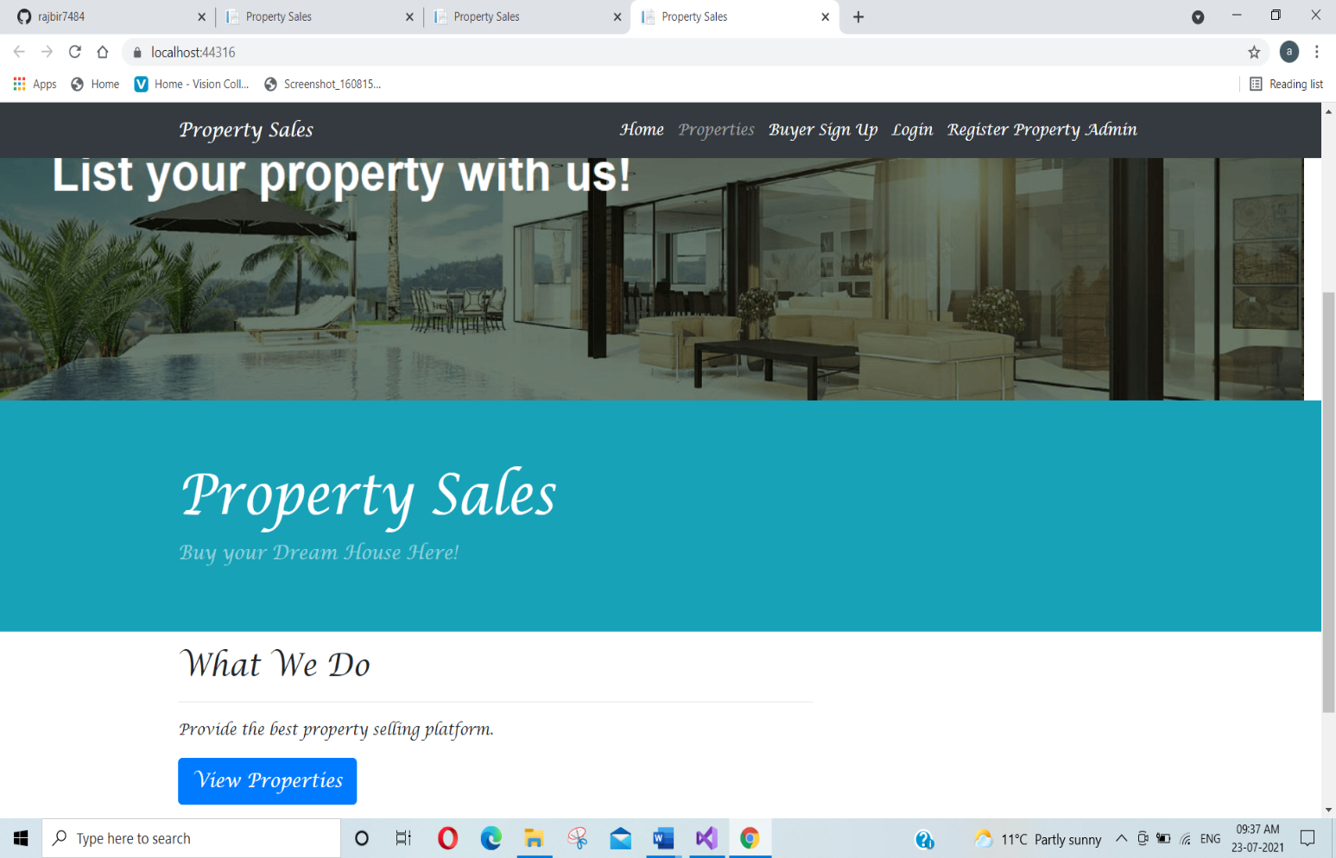This is the main page of the web application. All users can view this page of the application even without login. This page contains home, Properties, Buyer Sign up, login, Register Property admin menu options on the navigation bar.

## 

## Login Page

This Page will be used by the user and admin to login into the system.

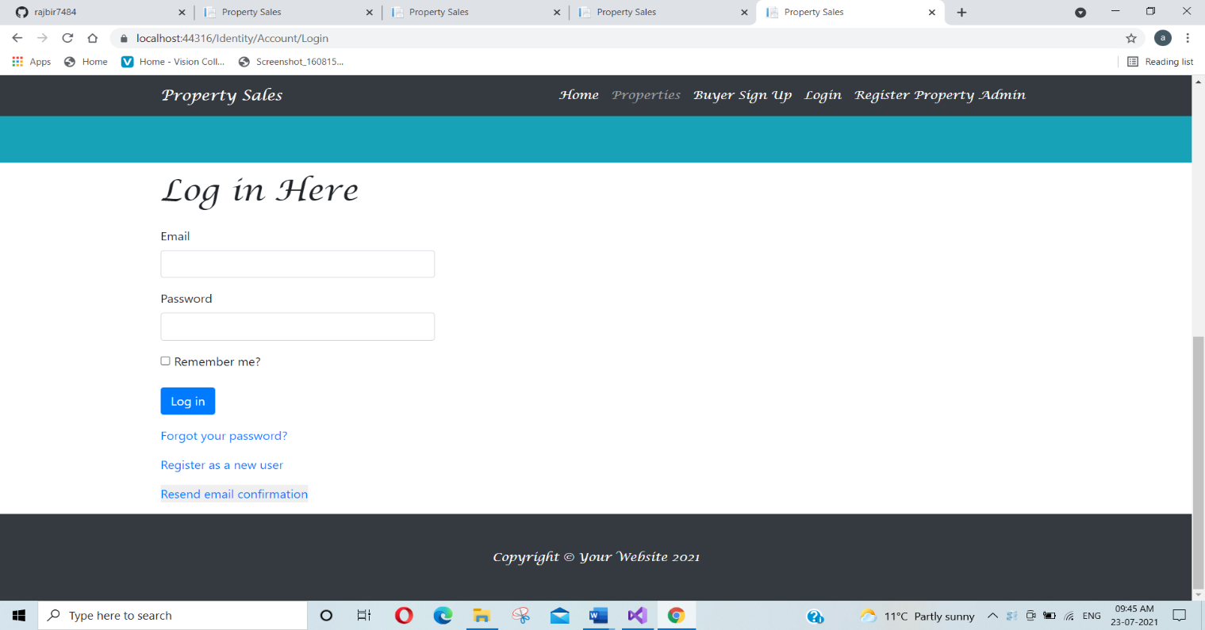

## Admin Register Property Page

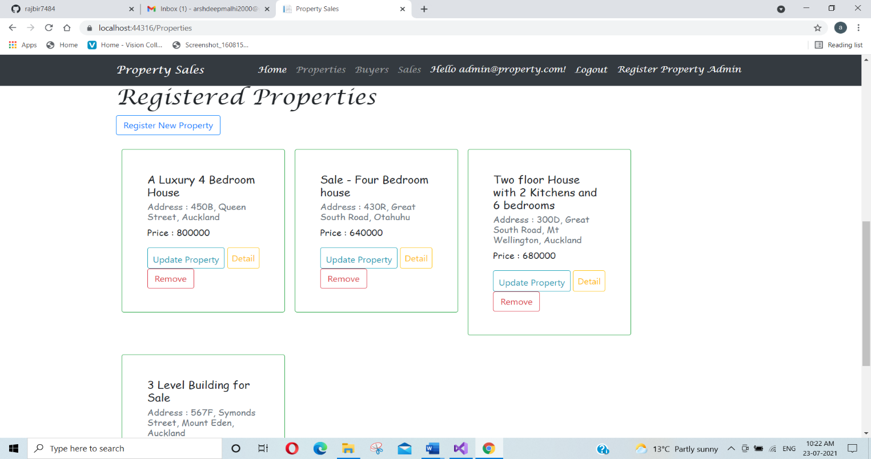Here admin can view the available properties that are registered. Admin can add a new property, update the existing one, remove them also check details for any property.

## Admin Buyer Page

This page provides the information about the Buyers who are registered with the application admin can delete and view their details.

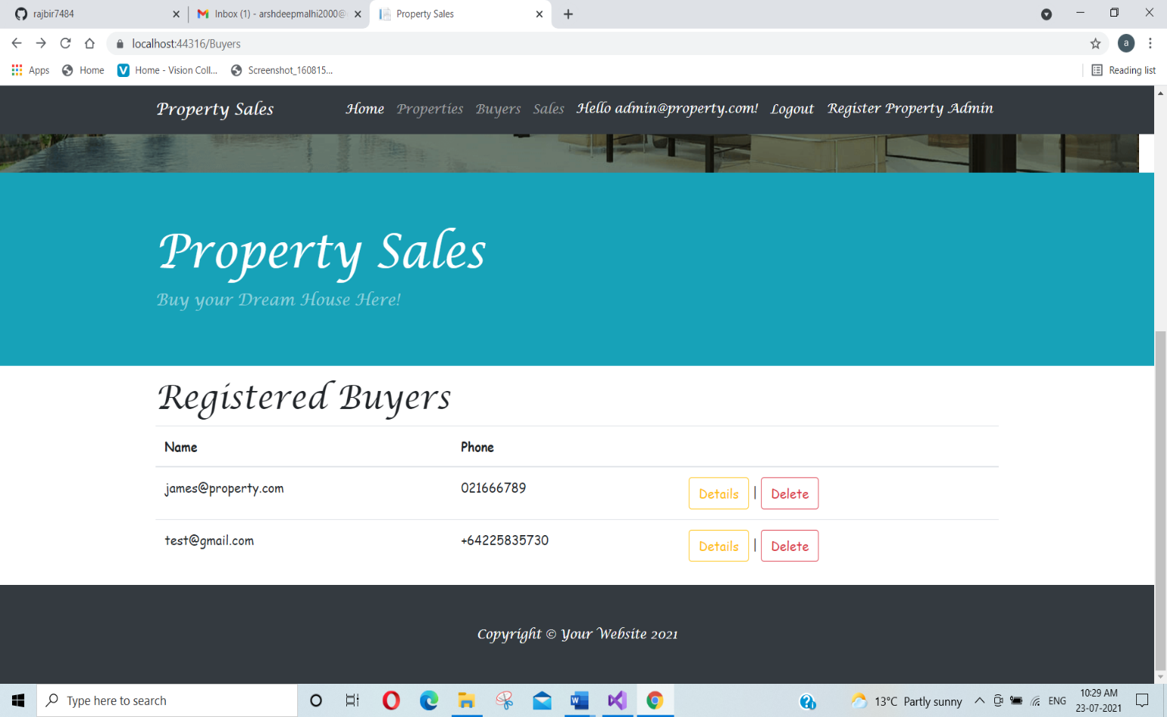

## 

## Admin Sales Transaction Page

In this page admin can delete and view details of sales transactions.

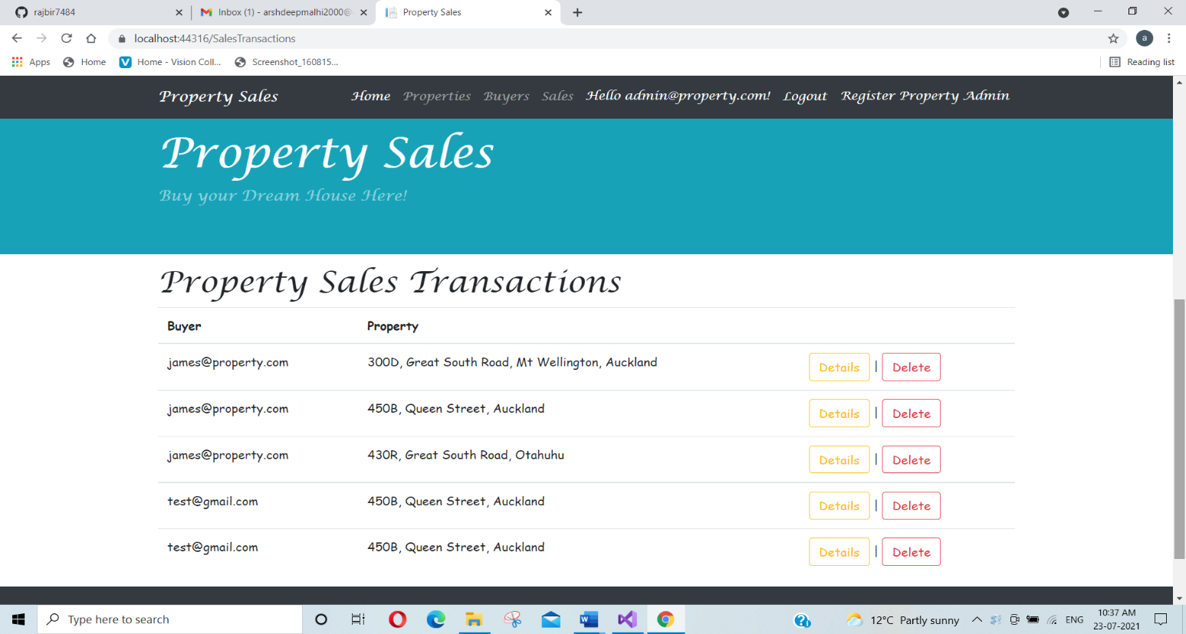

## User Registered Property Page

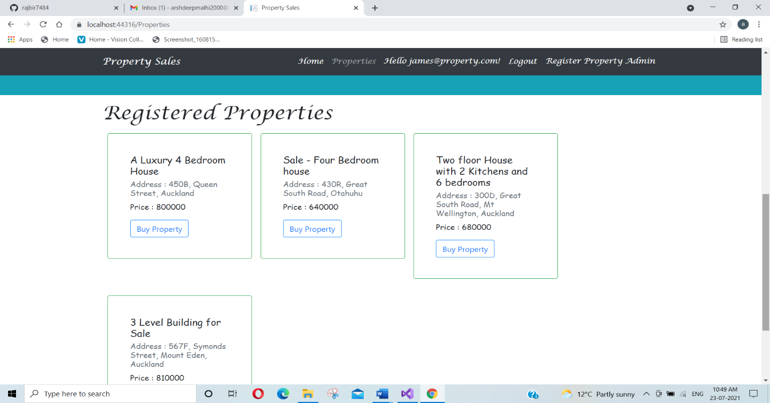In this page users can view all registered properties and can buy the one of his/her choice by clicking on buy property option.

## User Property Confirm Page

Once a user decides to buy a property by clicking on the buy property option, he/she will be navigated to this page to complete and confirm the sale.

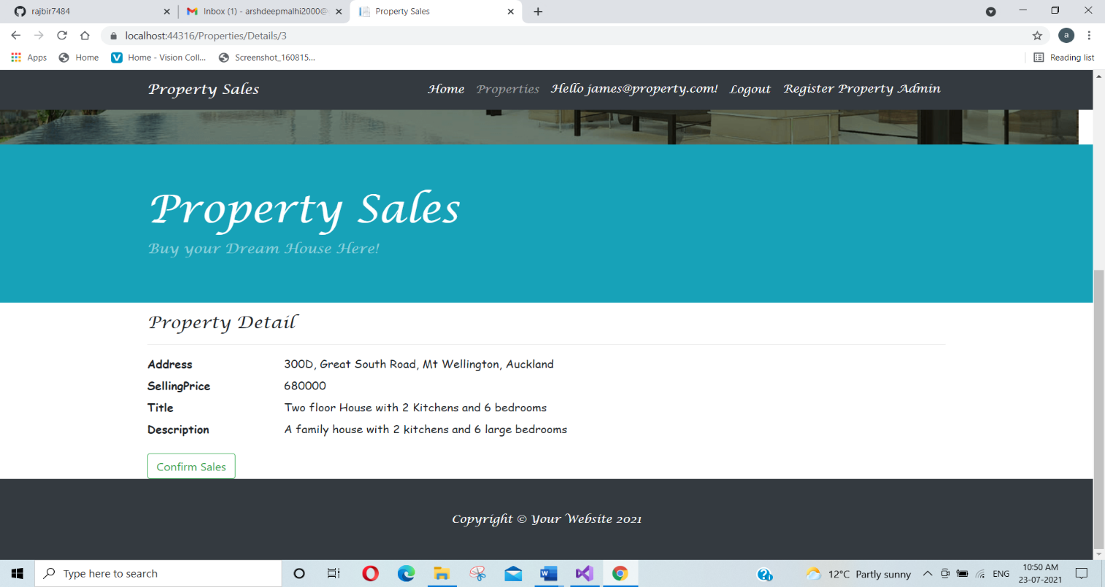

# Project Testing

In this web application main features are tested. Here I have tested the desktop version only. This report includes the accessibility, functionality, usability testing. There will be testing for navigation and performance as well. Testing is performed on Windows 10 Operating system, 64-bit i5 processor, 8 GB RAM, and google chrome web browser. Testing has the following Pass/Fail criteria:

* Completion of all test cases.
* Working of the main functionality
* Test competition percentage without errors

## User Activities

* User Registration
* Login/Logout
* View Properties
* Buy Properties
* Confirm Sale

## Admin Activities

* New Admin registration.
* Login/Logout
* Add, update, delete, check details for the properties
* Delete and details Check for Buyers
* Delete and detail check for Sales Transactions